ITCS216 Fundamentals of Database Systems (1/2026)
Workshop: Mapping EERD to the Relational Model
Student ID: __________________ | Name: __________________________ | Section: __________

Learning objective  Transform a given EERD into a relational model by applying the 8-step transformation procedure and explaining key mapping decisions. | Instructions  - Work through Steps 1-8 in order.  - Show the schema after each applicable step; do not jump directly to the final answer.  - Clearly mark PK and FK attributes.  - If a step does not apply, write “Not applicable” and briefly state why.  - For Step 8, circle one option and justify your choice.  - Submit by the end of the class.

Given EERD
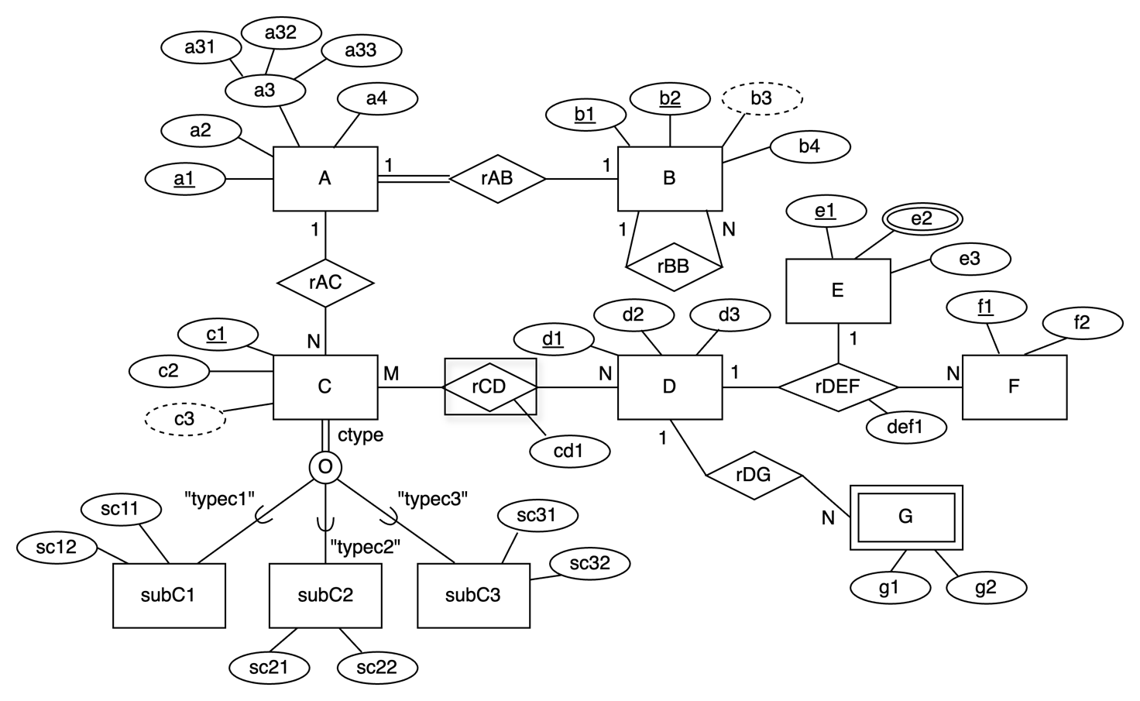

Step 1 - Transform regular entities
- Create one relation for each regular entity.
- Map simple attributes directly; replace composite attributes with their component attributes.
- Identify the primary key of each relation.

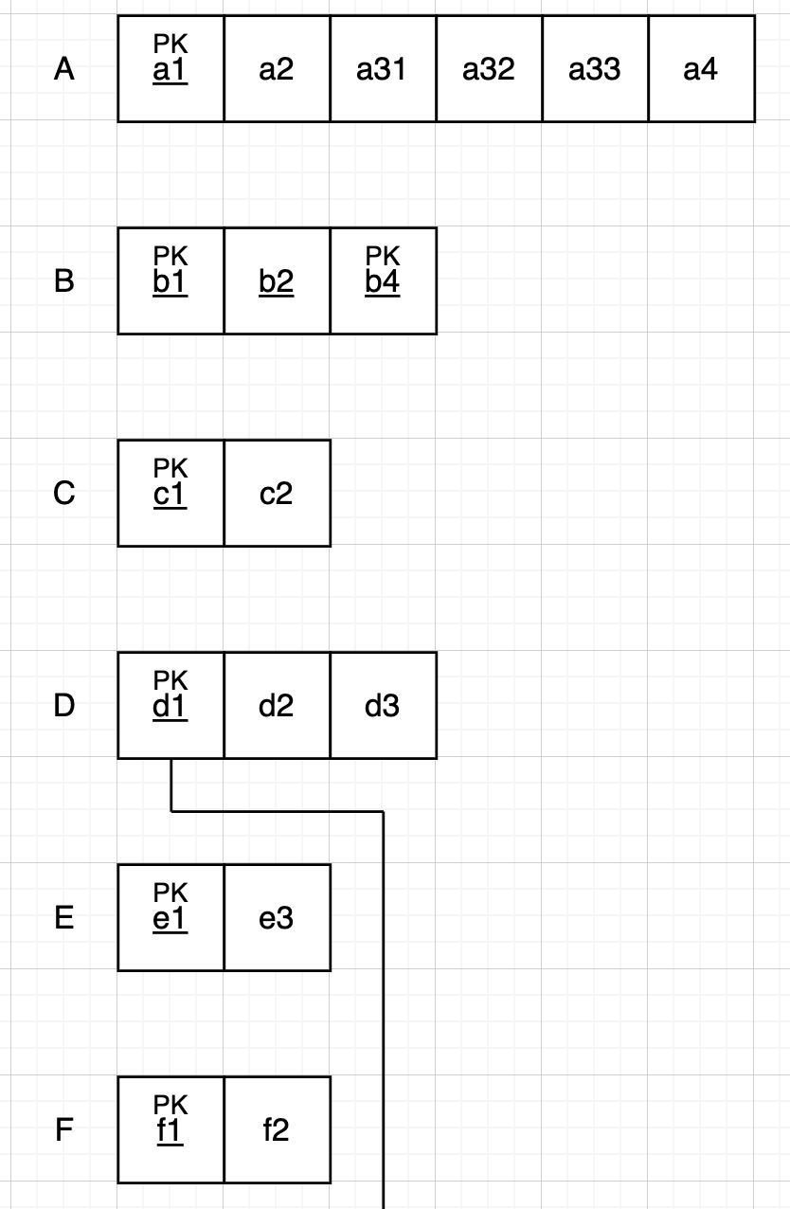

Step 2 - Transform weak entities
- Identify the weak entity and its owner/parent entity.
- Include the parent’s PK as an FK in the weak-entity relation.
- State the PK of the weak-entity relation.

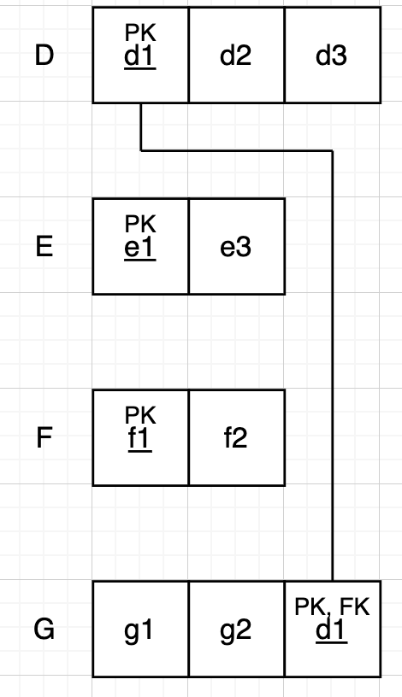

Step 3 - Transform binary 1:1 relationships
- Identify the 1:1 relationship(s).
- Choose which relation receives the foreign key.

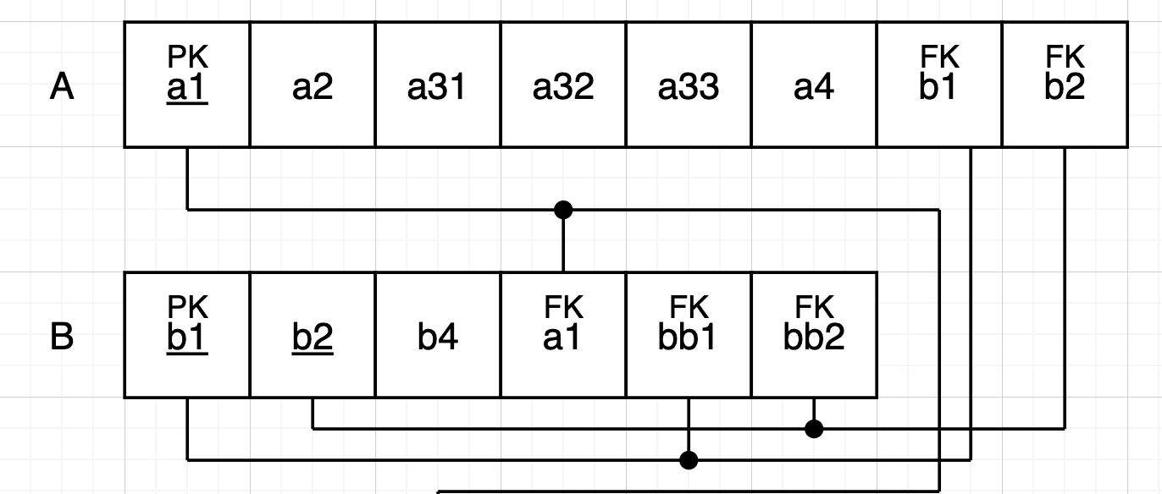

Step 4 - Transform binary 1:N relationships
- Identify each 1:N relationship.
- Place the PK of the “1” side as an FK in the relation on the “N” side.
- Include any relationship attributes, if applicable.

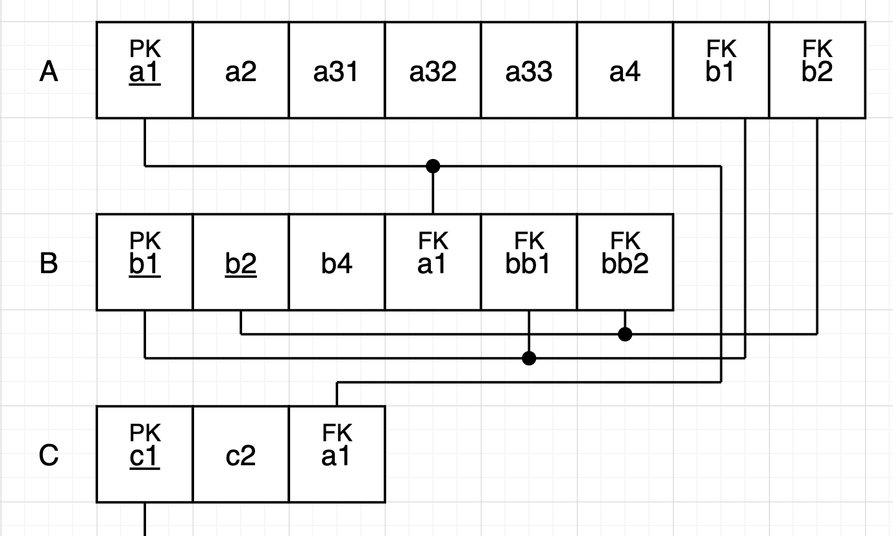

Step 5 - Transform binary M:N relationships
- Create a new relation for each M:N relationship.
- Include the PKs of participating entities as FKs and identify the resulting PK.
- Include relationship attributes, if any.

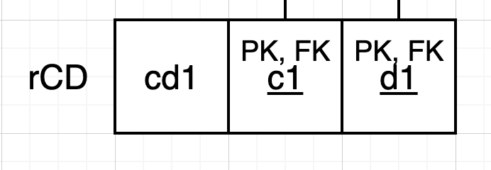

Step 6 - Transform multivalued attributes
- Create a new relation for each multivalued attribute.
- Include the owner entity’s PK as an FK and state the PK of the new relation.
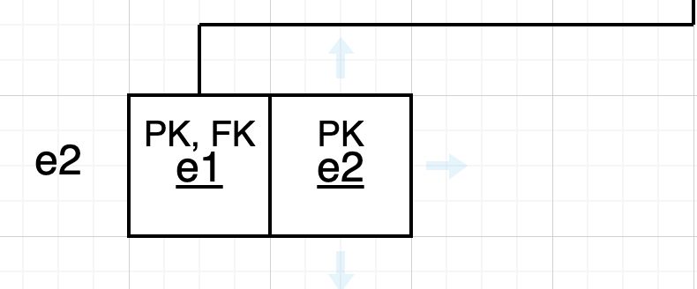

Step 7 - Transform N-ary relationships
- Create a new relation for the N-ary relationship.
- Include the PKs of all participating entities as FKs.
- Determine the PK based on the cardinality constraints and include any relationship attributes.

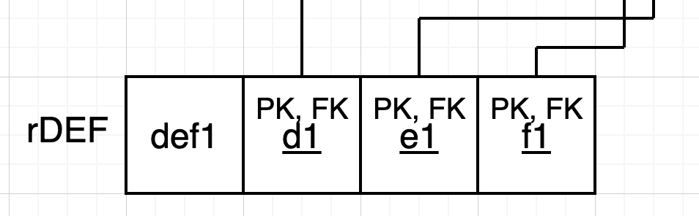

Step 8 - Transform specialization / generalization
Circle one mapping option: 8A 8B 8C 8D
- State the specialization constraints you observe.
- Briefly explain why the selected option is appropriate.
- Write the resulting relation(s) and clearly mark PK/FK attributes.
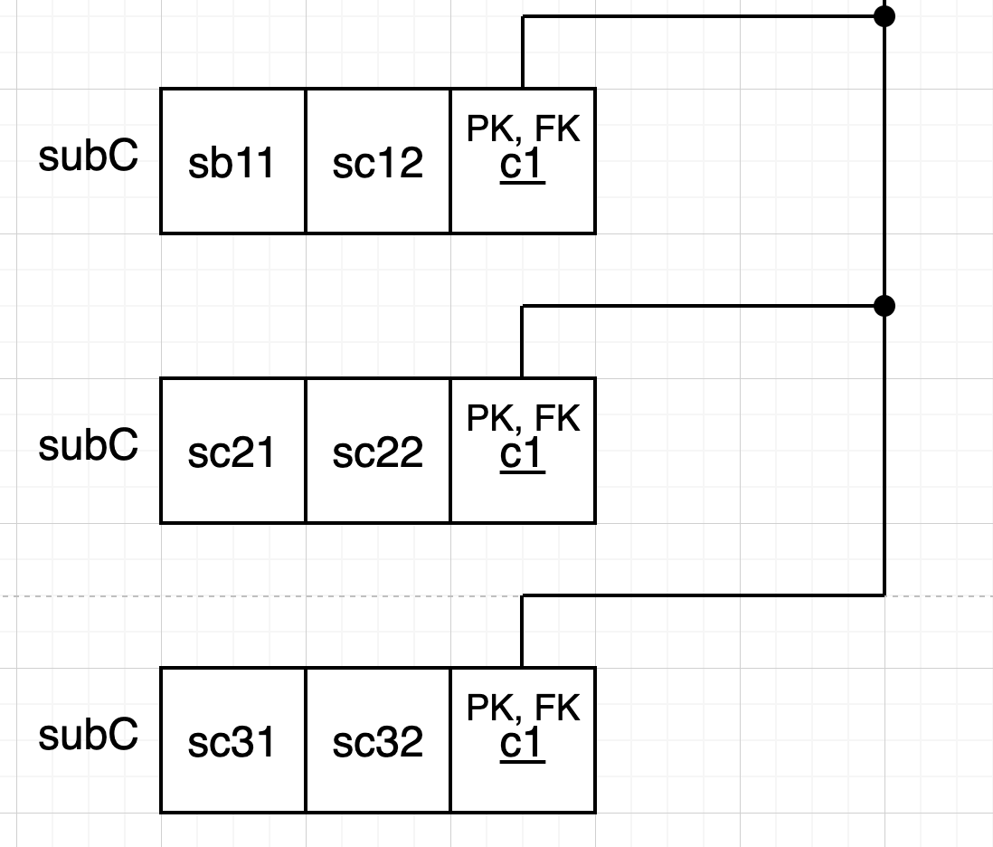

Final relational model
Write the complete final schema. Clearly mark PK and FK attributes in every relation.

